GRADE 7 ACCELERATED · UNIT 2 · LESSON 1
Square Values
Additional Practice 7A.02.01 ANSWER KEY

1. Complete the table. Each area is the side length multiplied by itself.
Side s | 6 | 7 | 8 | 9 | 10 | 11 | 12 | 13 | 14 | 15
Area s² | 36 | 49 | 64 | 81 | 100 | 121 | 144 | 169 | 196 | 225

225 is the largest perfect square the Grade 8 FAST will ask for, so this row is the ceiling. A student who writes 30 for s = 15 has multiplied by 2.
2. Select ALL of the numbers below that are perfect squares.
☒ | 4 | ☐ | 12
☒ | 25 | ☐ | 32
☐ | 50 | ☒ | 81
☐ | 90 | ☒ | 121
☐ | 150 | ☒ | 169

Five of the ten. For each one selected, ask which whole number was squared: 2, 5, 9, 11, 13.
For questions 3 through 5, find the area of a square with the side length given.
3. Side length 15 units
Area = 15² = 15 × 15 = 225 square units
4. Side length  meters
Area =  × = 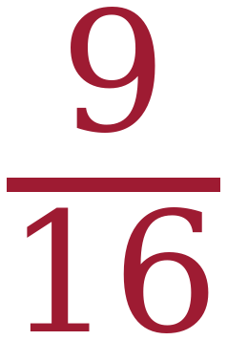 m²
Square the top and square the bottom. The answer is not 6/8.
5. Side length 1.2 units
Area = 1.2 × 1.2 = 1.44 square units
A student who answers 2.4 has doubled instead of squaring.
For questions 6 through 8, find the length of one side of a square with the area given.
6. Area 169 square inches
13 × 13 = 169, so the side is 13 inches.
7. Area 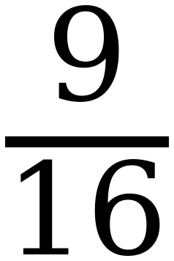 square meters
3 × 3 = 9 and 4 × 4 = 16, so the side is m.
8. Area 0.64 square units
0.8 × 0.8 = 0.64, so the side is 0.8 units.
A student who answers 0.08 has lost a decimal place. Squaring 0.08 gives 0.0064.
Questions 9 and 10 use the equation y = x².
9. Complete the table of values. Then plot the points on the grid.
x | Substitute into y = x² | Coordinates (x, y)
−3 | y = (−3)² = 9 | (−3, 9)
−2 | y = (−2)² = 4 | (−2, 4)
−1 | y = (−1)² = 1 | (−1, 1)
0 | y = (0)² = 0 | (0, 0)
1 | y = (1)² = 1 | (1, 1)
2 | y = (2)² = 4 | (2, 4)
3 | y = (3)² = 9 | (3, 9)

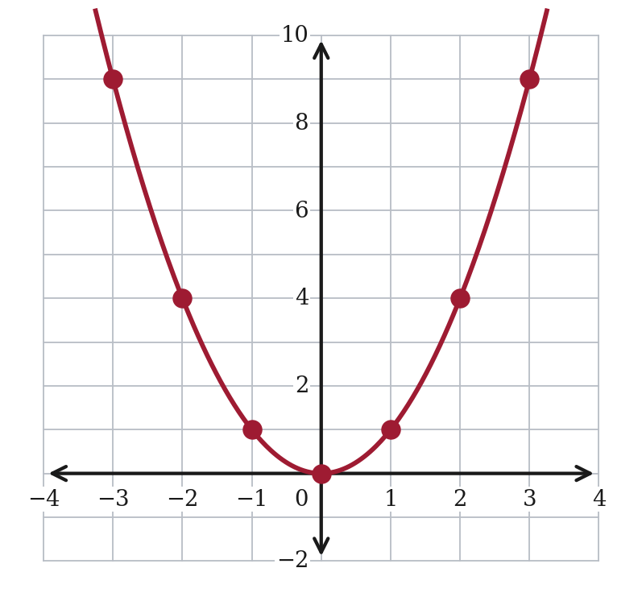
The two ends, (−3, 9) and (3, 9), are the pair to point at: different x, same y.
10. A classmate says the graph of y = x² is always above the x-axis. Is the classmate right? Explain.
Not quite. The graph never goes below the x-axis, but at x = 0 it touches it.
0 × 0 = 0, so the point (0, 0) is on the x-axis, not above it.
This is the same distinction as question 10 of the worksheet, asked from the other direction. “Never below” is correct; “always above” is not.
11. Can a square have an area of 20 square units? If it can, name the two whole numbers its side length falls between. Explain how you know.
Yes. The side is between 4 and 5.
4 × 4 = 16, which is too small, and 5 × 5 = 25, which is too big.
The side is not a whole number.
The point needs 4 and 5 named and both products given as the reason.

